Hospital Systems

**Description: -**

* The Project is to develop a working model for a hospital system. Will be able to manage and view patient details through a user interface.
* Develop an efficient and optimal database model that helps in easy retrieval and insertion of data.
* Generate useful reports based on the data model and project it in the user interface.

**Assumptions of project: -**

* The User interface provides a convenient way of providing key data inputs for massively impacting data reports behind the scenes.
* The data model that is developed is easily extensible and generic.
* The reports help physicians easily to get a grasp of patients with frequently same diagnoses, which helps the physicians to concentrate more on those cases and know more about it.

**ERD representation: -**

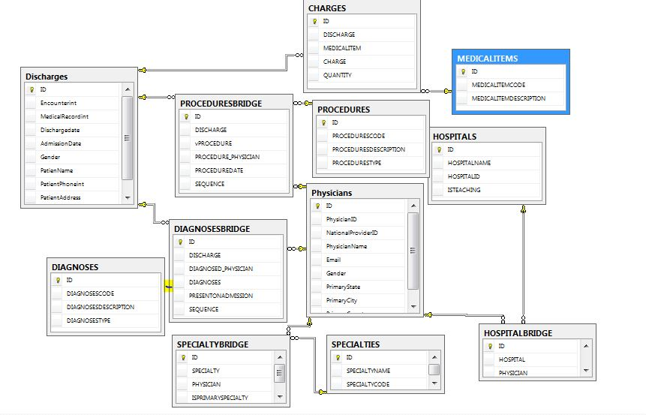

**ERD to Relational Database: -**

|  |  |  |
| --- | --- | --- |
| **Table** | **Primary Key** | **Foreign Keys** |
| Physicians | ID int; | - |
| Discharges | ID int; | - |
| Hospitals | ID int; | - |
| MedicalItems | ID int; | - |
| Diagnoses | ID int; | - |
| Procedures | ID int; | - |
| DiagnosesBridge | ID int; | Discharge, Diagnosed_Physician, Diagnoses |
| Procedures Bridge | ID int; | Discharge, Procedure_Physician, Procedures |
| Charges | ID int; | Discharge, Medical Items |
| Specialties | ID int; | - |
| SpecialtyBridge | ID int; | Physician, Specialty |
| HospitalBridge | ID int; | Physician, Hospital |

Datadbase creation Script attachment: -



**Functional Dependencies: -**

|  |  |
| --- | --- |
| **Tables** | **Dependent Tables** |
| Diagnoses Bridge | Discharges, Physicians, Diagnoses |
| Procedures Bridge | Discharges, Physician, Procedures |
| Charges | Discharges, Medical Items |
| Specialty Bridge | Physicians, Specialties |
| Hospital Bridge | Physicians, Hospitals |

**Normalize of the table: -**

|  |
| --- |
| **Table** |
| Physicians |
| Discharges |
| Hospitals |
| MedicalItems |
| Diagnoses |
| Procedures |
| DiagnosesBridge |
| ProceduresBridge |
| Charges |
| Specialties |
| SpecialtyBridge |
| HospitalBridge |

**Table Constraints: -**

* Physicians Discharges

|  |  |
| --- | --- |
| **Columns** | **Constraints** |
| ID | NUMBER not null primary key, |
| PhysicianID | varchar2(10) not null, |
| NationalProviderID | varchar2(15) not null, |
| PhysicianName | varchar2(25) not null, |
| Email | varchar2(20) not null, |
| Gender | varchar2(10), |
| PrimaryState | varchar2(2), |
| PrimaryCity | varchar2(20), |
| PrimaryCountry | varchar2(20) not null |

|  |  |
| --- | --- |
| **Columns** | **Constraints** |
| ID | NUMBER not null primary key, |
| EncounterNumber | numeric(25) not null, |
| MedicalRecordNumber | numeric(25) not null, |
| Dischargedate | date not null, |
| AdmissionDate | date not null, |
| Gender | varchar(10) not null, |
| PatienName | varchar(30) not null, |
| PatientPhoneNumber | varchar(30) not null, |
| PatientAddress | varchar(255) not null |

* Medical Items

|  |  |
| --- | --- |
| **Columns** | **Constraints** |
| ID | NUMBER not null primary key, |
| MEDICALITEMCODE | varchar2(5) not null, |
| MEDICALITEMDESCRIPTION | VARCHAR2(255) not null |

* Diagnoses

|  |  |
| --- | --- |
| **Columns** | **Constraints** |
| ID | NUMBER not null primary key, |
| DIAGNOSESCODE | VARCHAR2(10) not null, |
| MEDICALITEMDESCRIPTION | VARCHAR2(255) not null, |
| DIAGNOSESTYPE | VARCHAR2(2) not null |

* Procedures Specialties

|  |  |
| --- | --- |
| **Columns** | **Constraints** |
| ID | NUMBER not null primary key, |
| SPECIALTYNAME | varchar2(255) not null, |
| SPECIALTYCODE | VARCHAR2(4000) not null |

|  |  |
| --- | --- |
| **Columns** | **Constraints** |
| ID | NUMBER not null primary key, |
| PROCEDURESCODE | VARCHAR2(10) not null, |
| PROCEDURESDESCRIPTION | VARCHAR2(255) not null |
| PROCEDURESTYPE | VARCHAR2(2) not null |

* Charges Diagnoses Bridge

|  |  |
| --- | --- |
| **Columns** | **Constraints** |
| ID | NUMBER not null primary key, |
| DISCHARGE | NUMBER not null, |
| DIAGNOSED_PHYSICIAN | NUMBER not null, |
| DIAGNOSES | NUMBER not null, |
| PRESENTONADMISSION | char(1) not null, |
| SEQUENCE | INT not null |

|  |  |
| --- | --- |
| **Columns** | **Constraints** |
| ID | NUMBER not null primary key, |
| DISCHARGE | NUMBER not null, |
| MEDICALITEM | NUMBER not null, |
| CHARGE | numeric (15) not null, |
| QUANTITY | int default 1 |

* ProceduresBridge HospitalBridge

|  |  |
| --- | --- |
| **Columns** | **Constraints** |
| ID | NUMBER not null primary key, |
| DISCHARGE | NUMBER not null, |
| Procedure_PHYSICIAN | NUMBER not null, |
| Procedure | NUMBER not null, |
| SEQUENCE | INT not null |
| ProcedureDate | Date |

|  |  |
| --- | --- |
| **Columns** | **Constraints** |
| ID | NUMBER not null primary key, |
| HOSPITAL | NUMBER not null, |
| PHYSICIAN | NUMBER not null |

* SpecialtyBridge

|  |  |
| --- | --- |
| **Columns** | **Constraints** |
| ID | NUMBER not null primary key, |
| SPECIALTY | NUMBER not null, |
| PHYSICIAN | VARCHAR2(255) not null |
| ISPRIMARYSPECIALTY | char(1) not null |

Queries in the application: -

* **Count of Diagnoses by a Physician**

Select count (distinct Discharge) from DiagnosesBridge;

* **Count of Procedures by a Physician**

Select count (distinct discharge) from proceduresbridge;

* **Total Charge for a Discharge**

Select sum(Charge)from charges

Group by discharge;